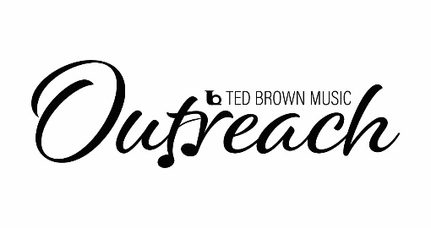
Instrument Request – Step up
Thank you for your interest in the Ted Brown Music Outreach Scholarship Program.
We are excited for you to continue in your musical career.

Who is eligible: Any student between the ages of 14 and 18 and can demonstrate financial need.

Date: ________________ School Name: _________________________________
Students Name: ____________________________________
Age: _______ M / F / NB Race: ______________ Hispanic / Non-Hispanic
Instrument Requested: _______________________________________________________________ Please be specific as for make and model if those are important. For Stringed instrument please note size.
Parent/Guardian Name: _____________________________________________
Address: _________________________________________________________
City: ______________________________ Zip Code: __________ Phone: ________________
Email: ____________________________________________
Please describe your musical goals and include any awards and honors (limit to 1 page)

Please describe your financial need. Include family size and household income.

Please attach a letter from your teacher recommending you for this scholarship (limit to 1 page)

How did you hear about the Ted Brown Music Outreach

The information provided is true and factual______________________________________________
Student
The information provided is true and factual______________________________________________
Parent

Mail: 6228 Tacoma Mall Blvd, Tacoma, WA 98409
Email: stephanie@tedbrownmusic.com
Fax: 253.572.1416 Phone: 253.272.3211

